**MACHINE READABLE ZONE DETECTOR**

**PROJECT REPORT**

**TASK**

Task is to detect Machine Readable Zone (Zone-VII) as described in the image below from given passport image with help of adaptive algorithms through MATLAB Code and return the output as text detected of Machine Readable Zones.

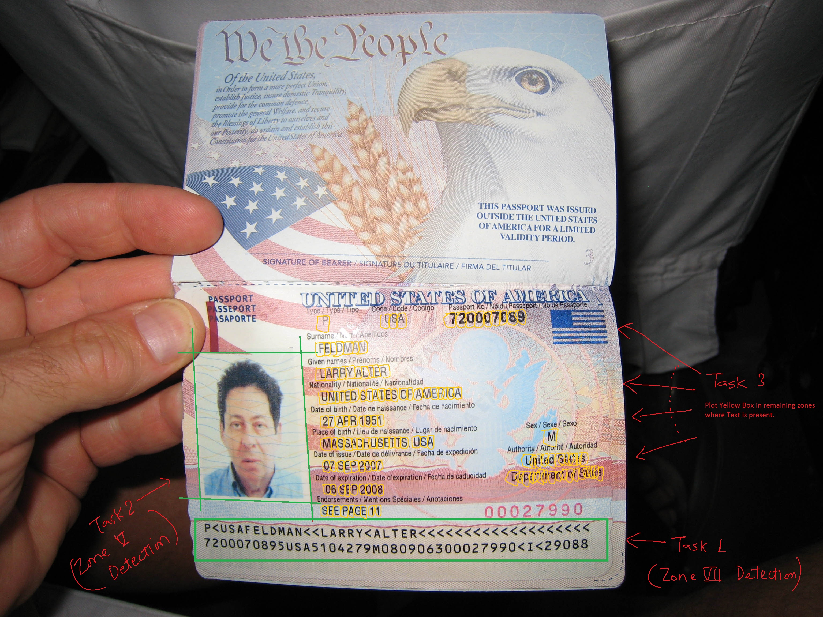

**SOLUTION**

This project is divided into two parts:

1. **Pre-processing the image**

Convert to gray scale and then to a black and white image. Morph the image using a rectangle block and erode it. This will convert the zone 7 into a black rectangular box





1. **Extracting MRZ**

Apply a MATLAB function called bounding box with a condition to only bound the region with the maximum rectangular area in the image

